


CHAPTER 1:Functions and their graphs
FUNCTIONS
1.1

Definition: If to every value (considered as real unless other-wise stated) of a variable x, which belongs to some collection
(Set) A, there corresponds one and only one finite value of the quantity y, then y is said to be a function (Single valued) of x or a dependent variable defined on the set A ; x is the argument or independent variable.
If to every value of x belonging to some set A there corresponds one or several values of the variable y, then y is called a multiple valued function of x defined on A.Conventionally the word "FUNCTION” is used only as the meaning of a single valued function, if not otherwise stated .
See a function as an operator, which takes an input and gives an output. The input is called the independent variable and the output, which depends on the input because of the operator, is called the dependent variable
Pictorially:
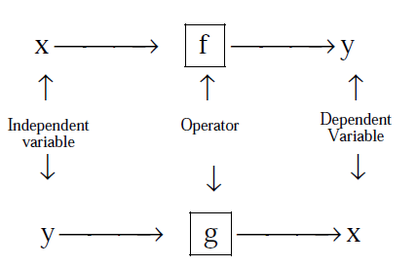
DOMAIN, CO-DOMAIN & RANGE OF A FUNCTION :
Let f : A → B, then the set A is known as the domain of f & the set B is known as co-domain of f . The set of all f images of elements of A is known as the range of f . Thus :
Domain of f = {a | a ∈ A, (a, f(a)) ∈ f}
Range of f = {f(a) | a ∈ A, f(a) ∈ B}
It should be noted that range is a subset of co-domain . Sometimes if only f (x) is given then domain is set of those values of ' x ' for which f (x) exists or is defined .

 Exercise1.1:

Q1: Given a function 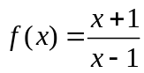,find 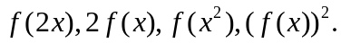
Q2: Given a function 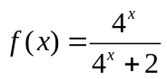,prove that 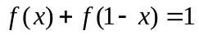,and also find the value of 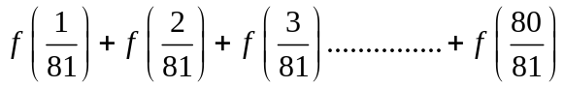.
Q3: if 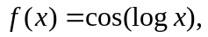then evaluate 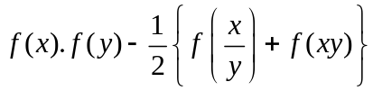
Q4: Given a function 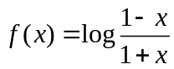.show that at 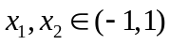,the following identity holds true.
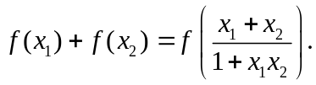Also prove that 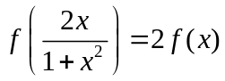.

Q5: Given a function  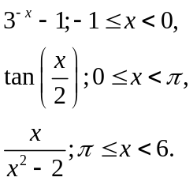Find 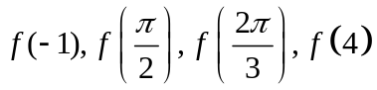.
Q6: In the square ABCD with side AB=2 a straight line MN is drawn perpendicular to AC .Denoting the distance from the vertex A to the line MN as x ,express through the x the area S of triangle AMN cut off from line MN .Find the area at x=√2/2 and x=2.
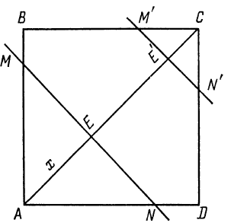
Q7: A function f satisfies the condition 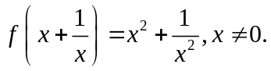Determine it and hence find f(3)

Q8: An polynomial expression f(x) of degree n satisfies the condition 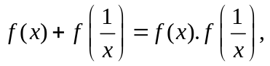then prove that 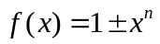
Q9: If for non zero x,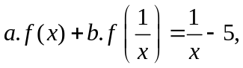where a≠b,then f(x) is equal to?
Q10: Let 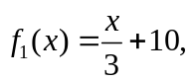for all x ∈R and 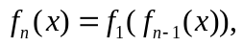for all n≥2.Then find 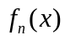.
Q11: If 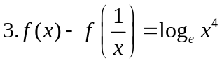,for x>0,Find 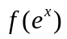
Q12: If 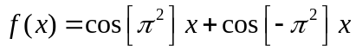 where [x] stands for the greatest integer function, then evaluate
f (π / 2), f (π), f (−π) and f (π / 4) .

1.2
Graphs of fuctions

S.NO | FUNCTION |  | GRAPH | DOMAIN | RANGE
a) | Constant function | f(x)=k | 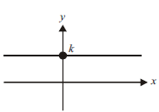 |  | {k}
b) | Identity function | f(x)=x | 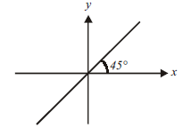
c) | Linear function | f(x)=mx+c | 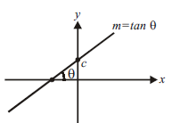
d) | Square function | f(x)=x² | 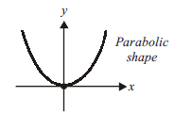 |  | [0,∞)
e) | Cube function | f (x) = x³ | 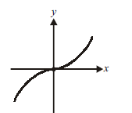
f) | Reciprocal function | f (x)=1/x | 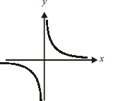 | 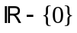
g) | Modulus Function | 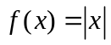 | 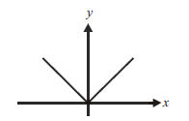 |  | [0,∞)
h) | Exponential function | 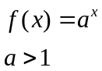 | 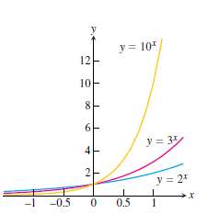 |  | (0,∞)
 |  | 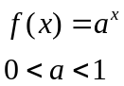 | 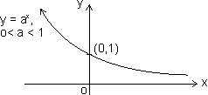 |  | (0,∞)
i) | Logarithmic function | 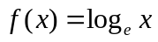 | 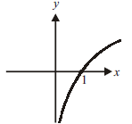 | (0,∞)
 |  | 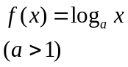 | 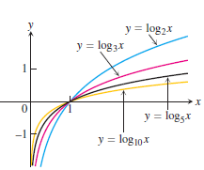 | (0,∞)
 |  | 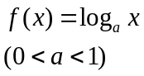 | 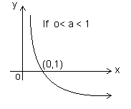 | (0,∞)
j) | Greatest integer function | 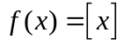 | 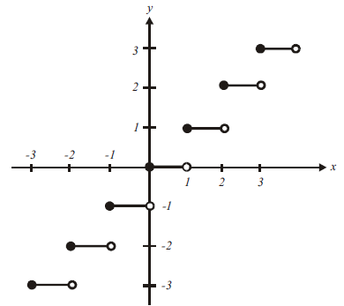 |  | 
k) | Fractional part | 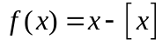 | 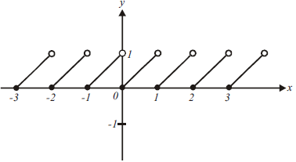 |  | [0,1)
l) | Square root | 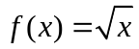 | 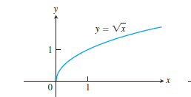 | [0,∞) | [0,∞)
m) | Cube root | 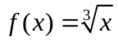 | 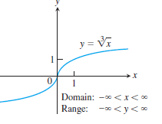
n) | Signum function | 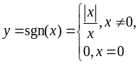 | 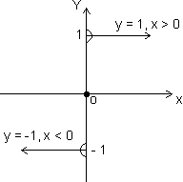 |  | {- 1, 0,1}

TRIGNOMETRIC FUNCTIONS
 | FUNCTION | PERIOD | GRAPH | DOMAIN | RANGE
a) | sinx | 2𝝅 | 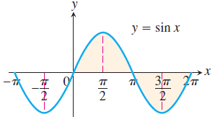 |  | [-1,1]
b) | cosx | 2𝝅 | 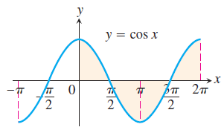 |  | [-1,1]
c) | tanx | 𝝅 | 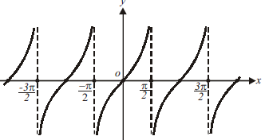 | 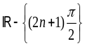
d) | cosecx | 2𝝅 | 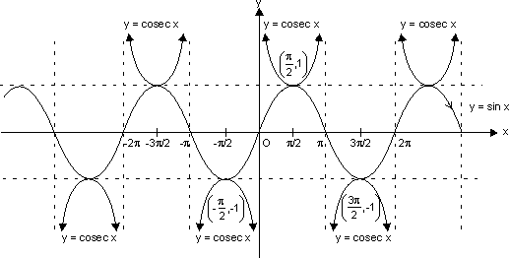 | 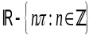 | 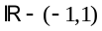
e) | secx | 2𝝅 | 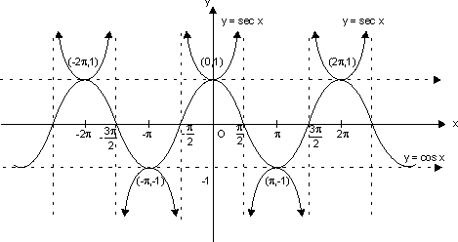
f) | cotx | 𝝅 | 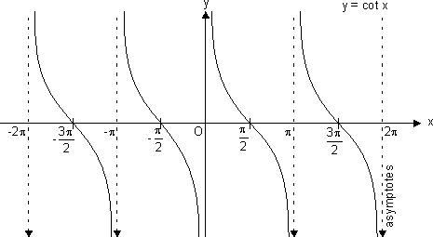

INVERSE TRIGNOMETRIC FUNCTIONS
 | FUNCTION | GRAPH | DOMAIN | RANGE
a) | 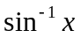 | 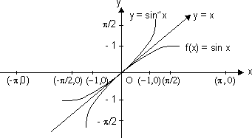 | [-1, 1] | 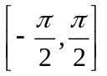
b) | 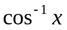 | 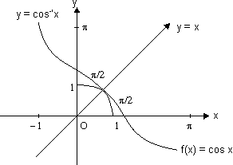 | [-1, 1] | 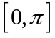
c) | 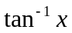 | 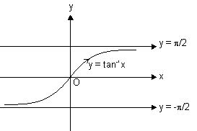
d) | 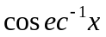 | 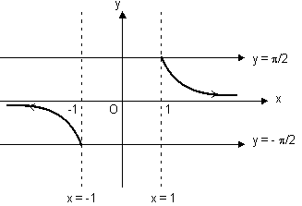 |  | 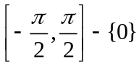
e) | 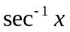 | 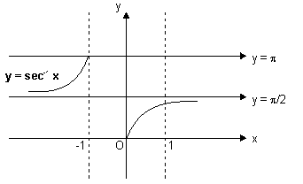 |  | 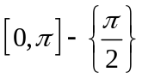
f) | 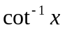 | 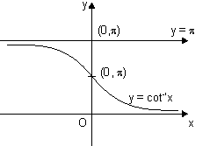 |  | 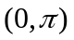
g) | sin(sin⁻¹x) | 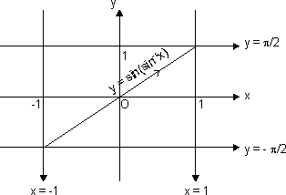 | [-1, 1] | [-1, 1]
h) | cos(cos⁻¹x) | 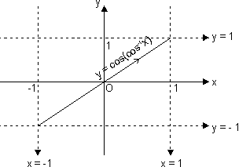 | [-1, 1] | [-1, 1]
i) | tan(tan⁻¹x) | 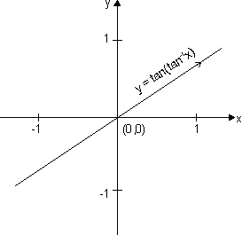
j) | cosec(cosec⁻¹x) | 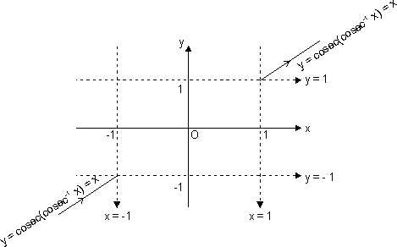
k) | sec(sec⁻¹x) | 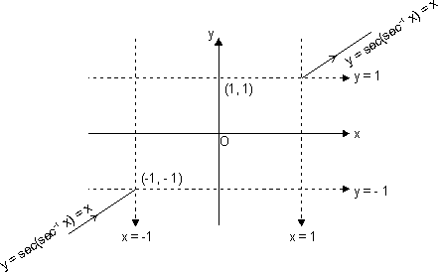
l) | cot(cot⁻¹x) | 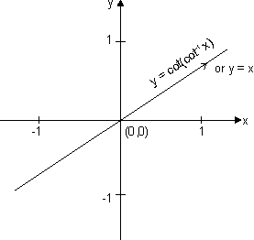

1.3
Properties,domain and range

Properties of some standard functions:
1. Properties of modulus function:
(i) |x| a - a x a (a 0)
(ii) |x| a x - a or x a (a )
(iii) |x + y| |x| + |y|
(iv) 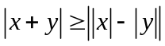
2. Properties of greatest integer function:
(i) [x] = x holds if x I (I is Integer).
(ii) [x + I] = [x] + I if I is integer.
(iii) [x + y] [x] + [y]
(iv) If [(x)] I, then (x) I.
(v) If [(x)] I, then (x) < I + 1
(vi) If [x] > n x n + 1, n I.
(vii) [- x] = - [x] if x I
& [- x] = - [x] - 1 if x I.
(viii) [x + y] = [x] + [x + y - [x]] for all x, y R.
(ix) [x] + 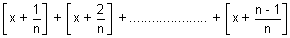
= [n x], n N N natural no.
3. Properties of fraction part of x
(i) {x} = x if 0 x< 1
(ii) {x} = 0 if x I
(iii) {- x} = 1 - {x} if x I
4. Properties of logarithmic function:
(i) log_{a}a = 1 (a>0,a≠1)
(ii) log_{e}(ab)= log_{e}a+ log_{e}b (a,b>0)
(iii) log_{e}(a/b)= log_{e}a- log_{e}b (a,b>0)
(iv) log_{e}a^{m}=m log_{e}a (a>0,m∈R)
(v) log_{b}a=1/( log_{a}b) (a,b>0 and a,b≠1)
(vi) log_{b}a= log_{m}a/ log_{m}a (a,b,m>0 ≠1)
(vii)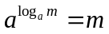 (a>0,a≠1;m>0)
(viii)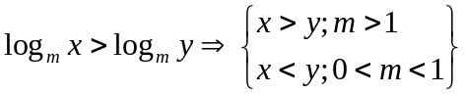
(ix)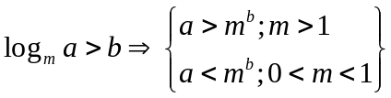
(x) 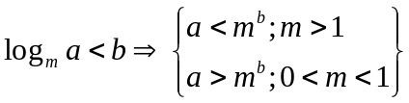
(xi)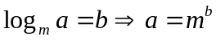 (m,a>0;m≠1b∈R)

Exercise1.2:
Q1: Solve the following equations:

- 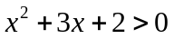
- 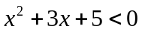
- 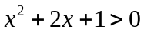
- 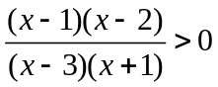
- 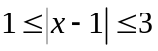
- 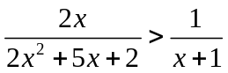
- 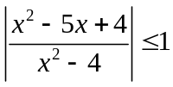
- 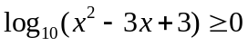
- 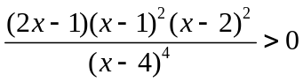
- 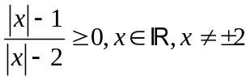
- 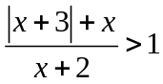
- 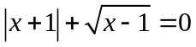
- 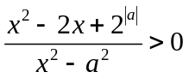
- 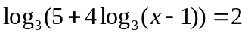
- 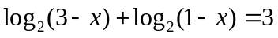
- 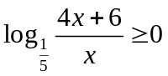
- 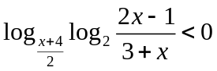
- 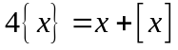

Exercise1.3:
Q1: Find the domains of the following functions, assuming the functions to be real for given

- 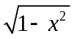
- 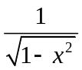
- 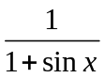
- 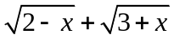
- 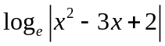
- 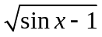
- 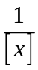
- 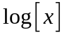
- 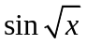
- 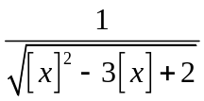
- 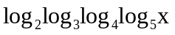
- 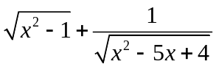
- 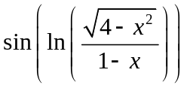
- 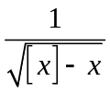
- 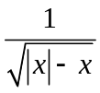
- 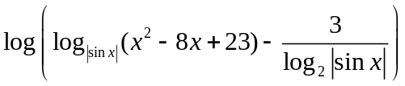
- 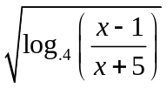
- 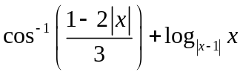
- 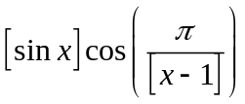
- 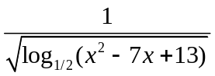

Q2: Find the domain of single valued function y = f(x) given by the equation 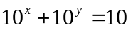

Exercise1.4:
Q1: Find the range of the following functions, assuming real functions given by

- x
- 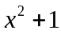
- 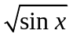
- 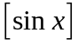
- 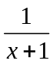
- 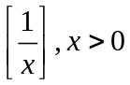
- 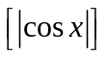
- 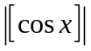
- 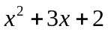
- 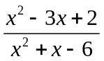
- 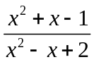
- 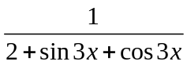
- 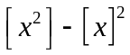
- 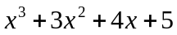
- 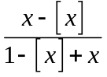
- 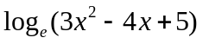
- 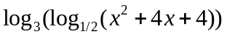

1.4
Analysis of a function

Even and odd functions
Definition: A function y=f(x) is an
Even function of x if 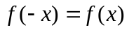
Odd function of x if 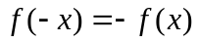
Graphs of even function are symmetric about y axis ,example 
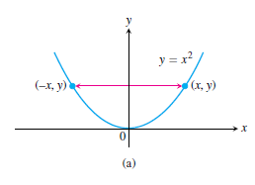
Graphs of odd function are symmetric about origin ,example 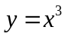
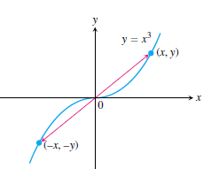

Increasing and decreasing function:
If the graph of a function climbs or rises as you move from left to right, we say that the function is increasing. If the graph descends or falls as you move from left to right, the function is decreasing

If 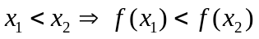 function is strictly increasing
If 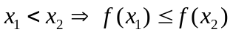 function is increasing

If 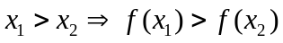 function is strictly deccreasing
If 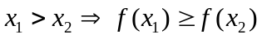 function is decreasing

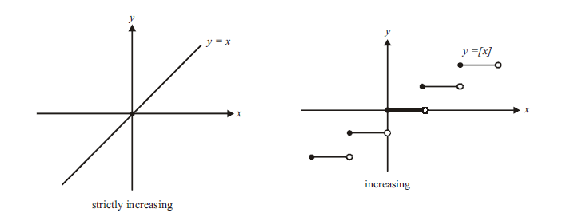
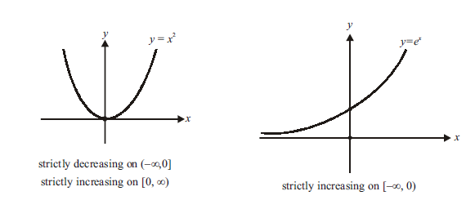
Periodic function:
A function ƒ(x) is periodic if there is a positive number T such that 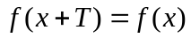 for every value of x. The smallest such value of T is the period of ƒ.
For example, sin x has periods 2π , 4π ,6π , −4π , 2nπ etc. but the fundamental period is 2π.

Properties of periodic function:
(i) If f(x) is periodic with period T, then, c.f(x), f(x + c) & f(x) ± c is periodic with period T.
eg. if sin x has period 2. Then f(x) = 5 sinx + 4 is also periodic with period 2.
(ii) If f(x) is periodic with period T, then, kf(cx + d) has period 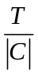
f(x) = 7 sin2x - 12 has period 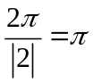as sinx is periodic with period .
(iii) If f₁(x), f₂(x) are periodic functions with periods T₁, T₂ respectively then; h(x) = af₁(x) ± bf₂(x) has period as
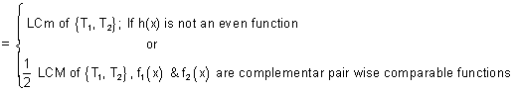
LCM of 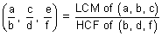
Note: LCM of rational and irrational is not possible. eg. 2. is irrational & 1 is rational.
Composite Function:
Let two function,
f : x Y₁ and g : Y₁ Y
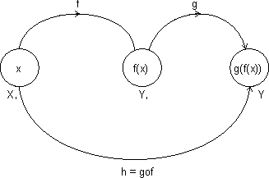
Let another function h : X Y
Such that
h(x) = g(f(x)) = (gof)(x)
domain (gof) = {x : x domain (f), f(x) domain (a)}
domain fog(x) = {x : x domain (g), g(x) domain f}
gof exist iff range of f domain of g
fog exist iff range of g domain of f.
Properties of composite function:
(i) f is even, g is even fog is even function.
(ii) f is odd, g is odd fog is odd function.
(iii) f is even, g is odd fog is even function.
(iv) f is odd, g is even fog is even function.
Exercise1.5:
Q1: Check weather the following functions  are even or odd
- 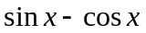
- 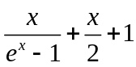
- 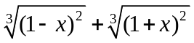
- 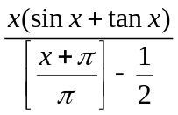
Q2: If the function f satisfies f (x + y) + f (x − y) = 2 f (x). f ( y) ∀ x, y∈R, and f (0)≠ 0, prove that f (x) is even.
Q3: If f is non-periodic and g is periodic, what can you say about f (
g(x)) and g ( f (x))?
Q4: What are the periods of the following functions f(x)=
- 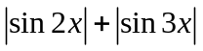
- 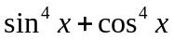
- 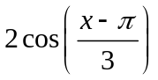
- 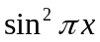
Q5: Prove that if f is increasing, f ⁻¹ is increasing and if f is decreasing, f ⁻¹ is decreasing
Q6: If 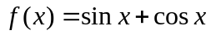 and 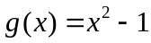 then find the interval in which g(f(x) is invertible?
Q7: If 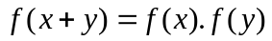∀ real x,y and 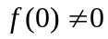 then prove that the function 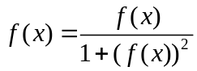 is an even function.
Q8: If 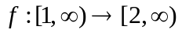 is given by 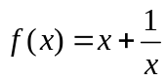,then find 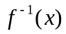(assuming bijective)
Q9: If 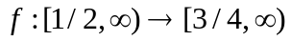 is given by 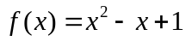,then find (assuming bijective)
Q10: Find the inverse of the following functions (assuming bijective)
- 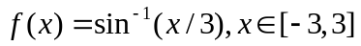
- 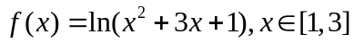
Q11: If 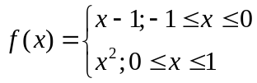 and 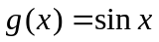. Then find 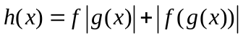

Mapping of a Function:
Mapping of function: A function exists only if,” to every element in domain there exists unique image in co domain.
f : A B
One - One Mapping (Injective): A function f: A B is said to bwe one-one mapping if different elements of A have different images in B. no two elements of set A can have same 'f' image
eg.
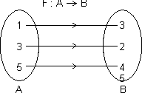
f(x) is one-one
Methods to find one-one mapping:
(1) Graphically: A fun. is one-one if no line 11 to x-axis meets graph of function at more than one point.
By Calculus: If f(x) is function and if f'(x) 0 v x domain i.e. increasing or f'(x) 0 v x domain i.e. decreasing, then one-one.
No. of one-one Mapping: If A & B are finite sets having m & h elements, then, no. of one-one function from A to B
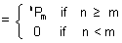
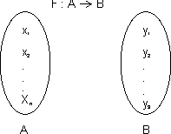
Many one Mapping: A mapping f : A B is many one if two or more elements of set A have the same image in B.
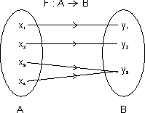
i.e. f(x³) = f(x₄) = y₃
Onto Function (Surjective): If function f : A B is such that each element of B is the 'f' image of at least one element in A.
i.e. range of f = co domain f(A) = B
Into Function: A function of f : A B is into if there exists an element in B having no pre image in A.
No. of one-one onto mapping (bijection): If A & B are finite sets & f : A B is a bijection.
Then A & B have same no. of elements.
Total no. of bijection A B = n !
Inverse function: Let f : A B be one-one & onto function then there exists a unique function.
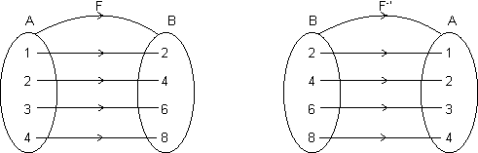
g : B A such that f(x) = y g(y) = x, v x A & y B
Then g is c/d inverse of F.
So, g = f⁻¹ : B A = {(f(x), x) | (x, f(x) f}
Domain of f = {1, 2, 3, 4} = range of f⁻¹
Range of f = {2, 4, 6, 8} = domain of f⁻¹.
Note: (1) Graph of y = f(x) and y = f⁻¹(x) are mirror images to each other.
(2) If f : A B & g : B C are two bijections, then gof : A C is bijection & (gof)⁻¹ = (f⁻¹og⁻¹).
(3) If fog = gof then either f⁻¹ = g or g⁻¹ = f and (fog)(x) = (gof)(x) = (x)
Exercise1.6:
Q1: Is 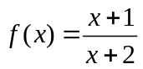 one one or many one?
Q2: Is 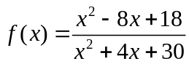 one one or many one?

Q3: Are the following functions into or onto?
- 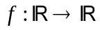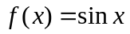
- 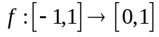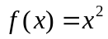
- 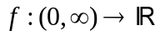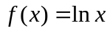
- 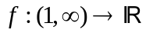

Exercise level 1:
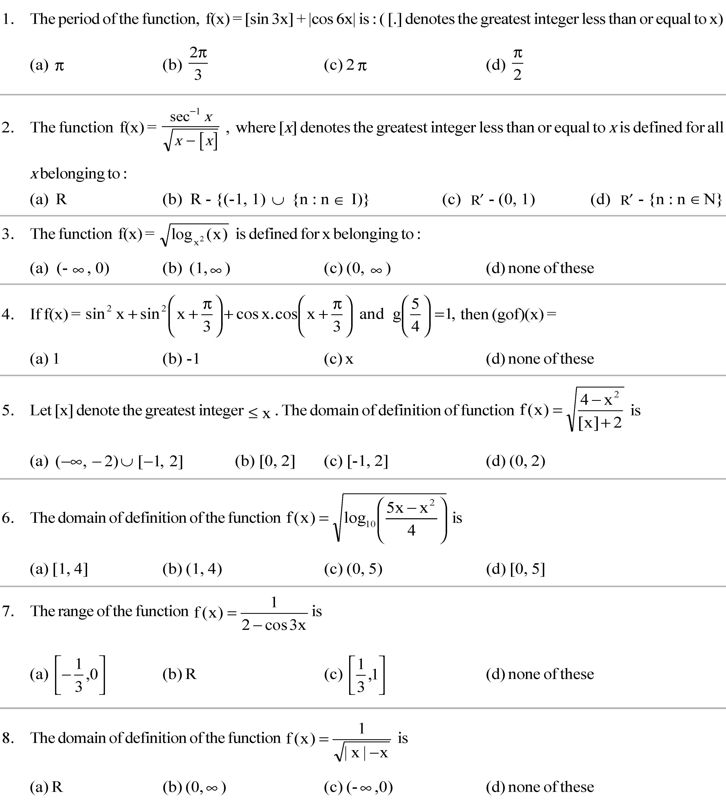
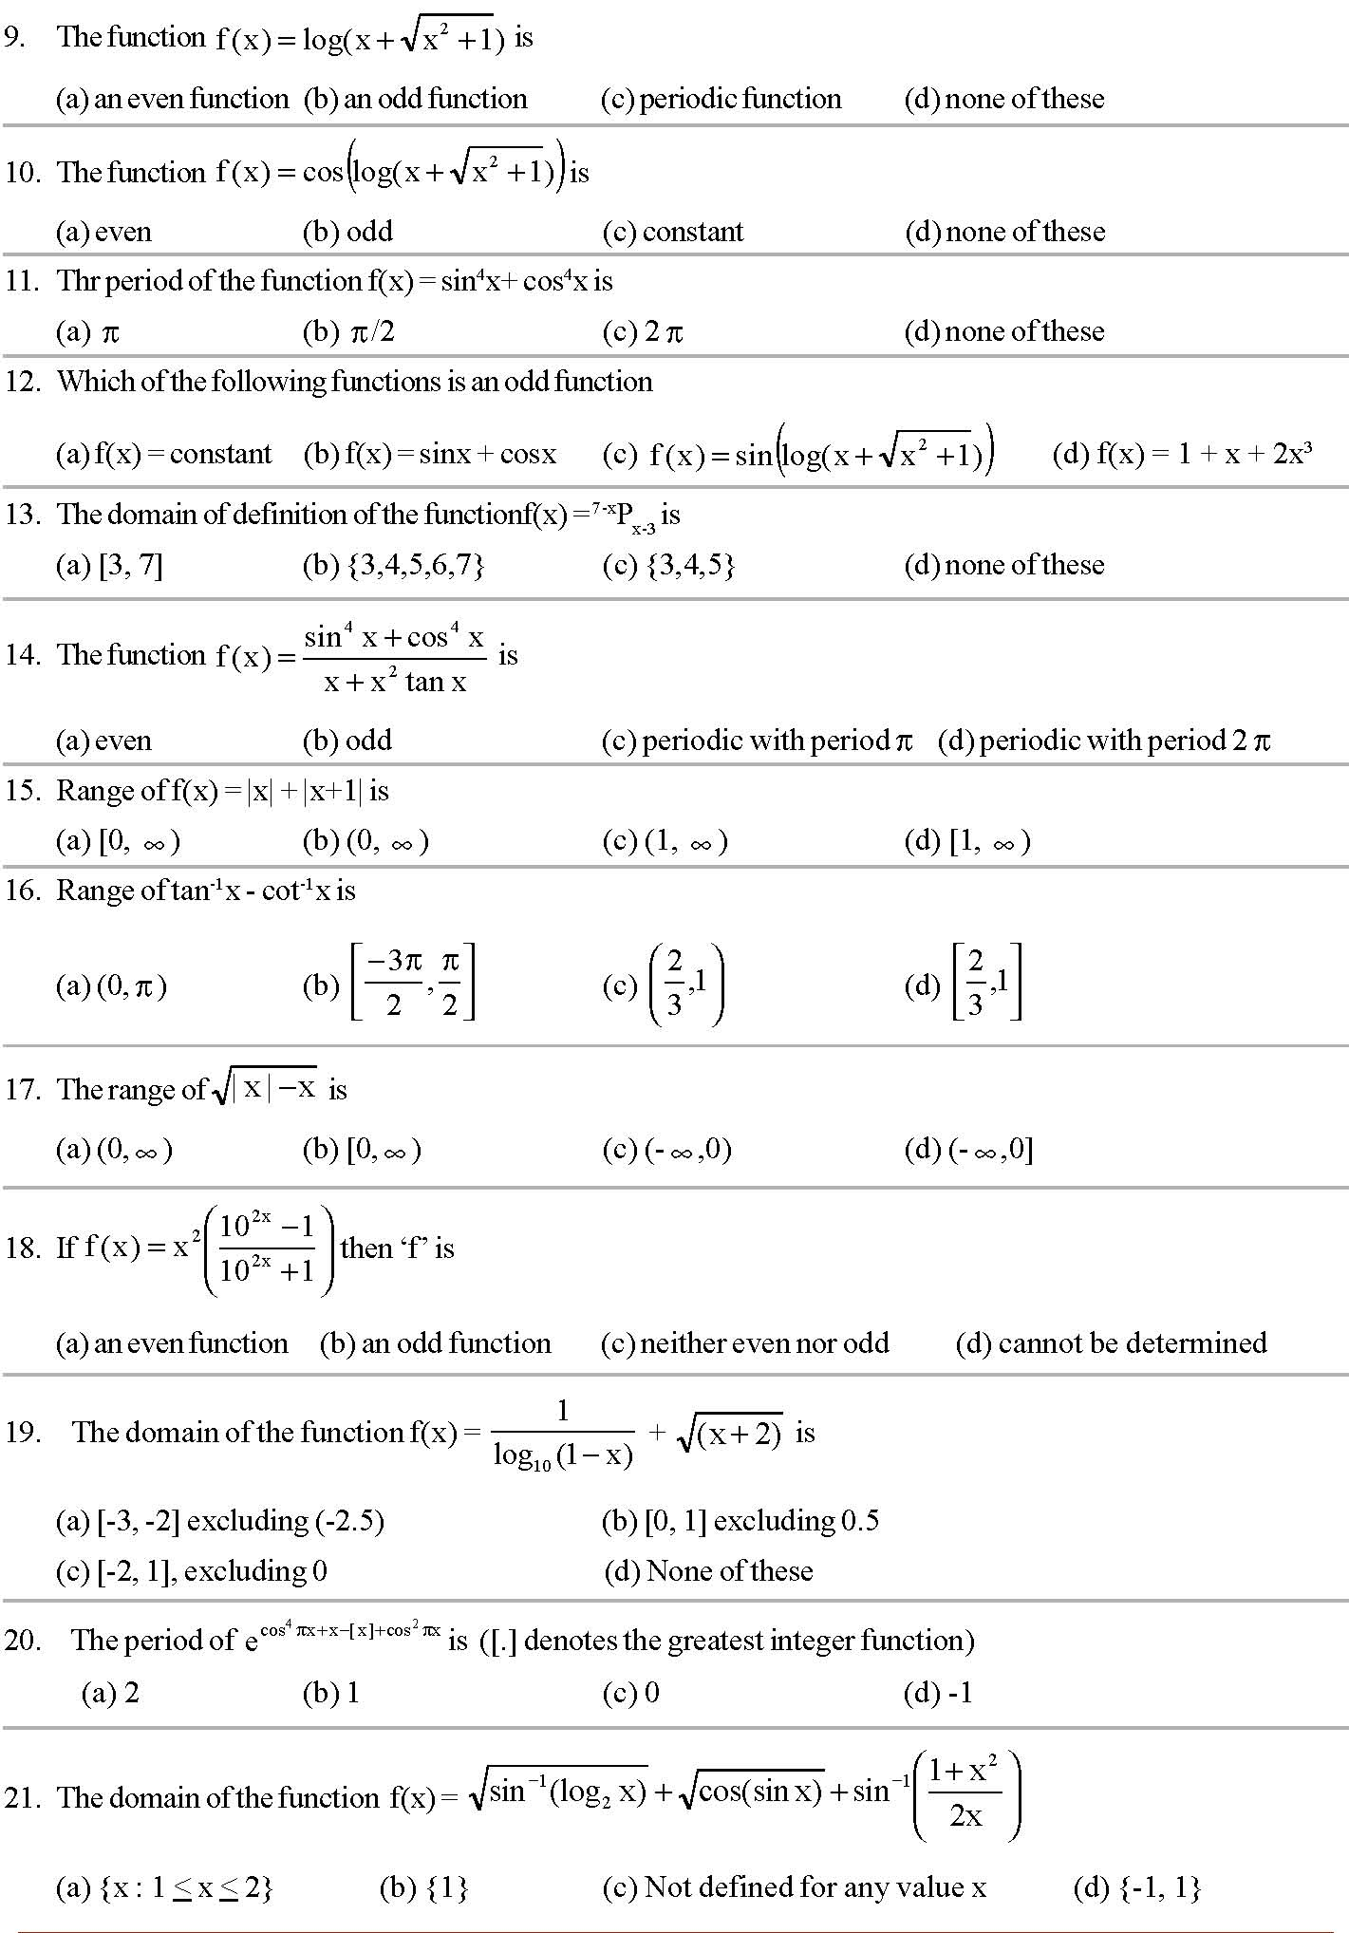
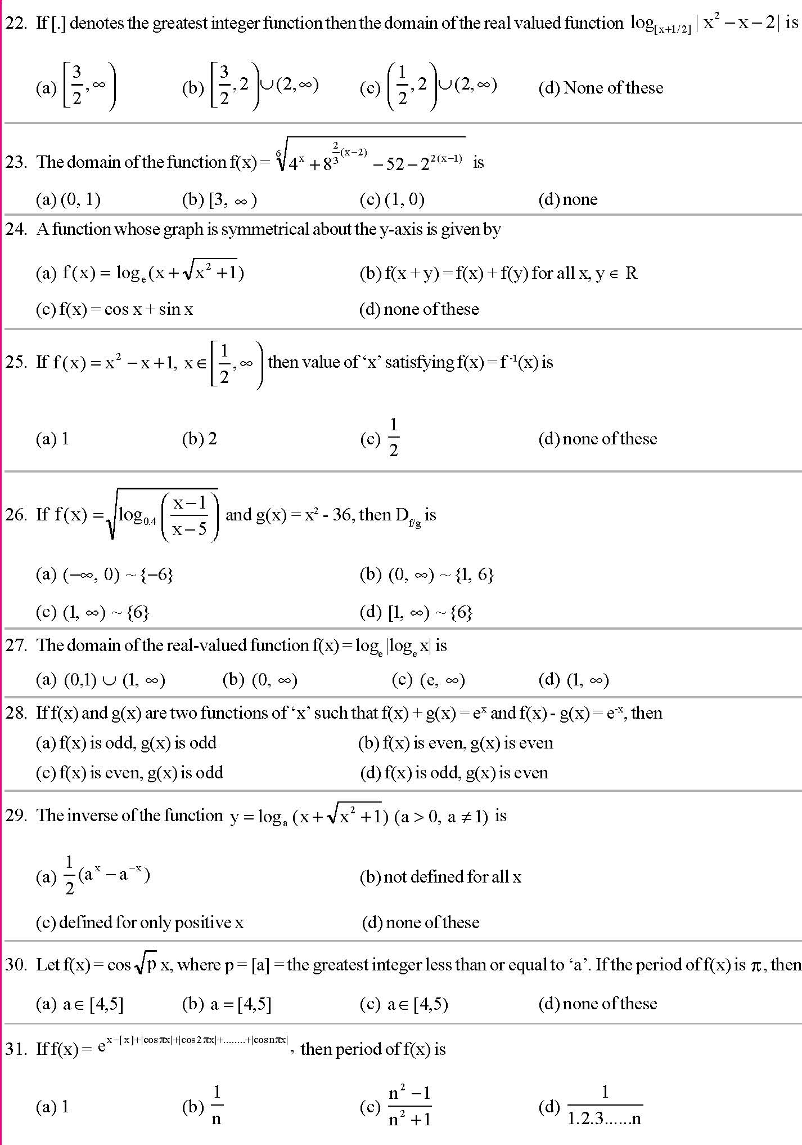
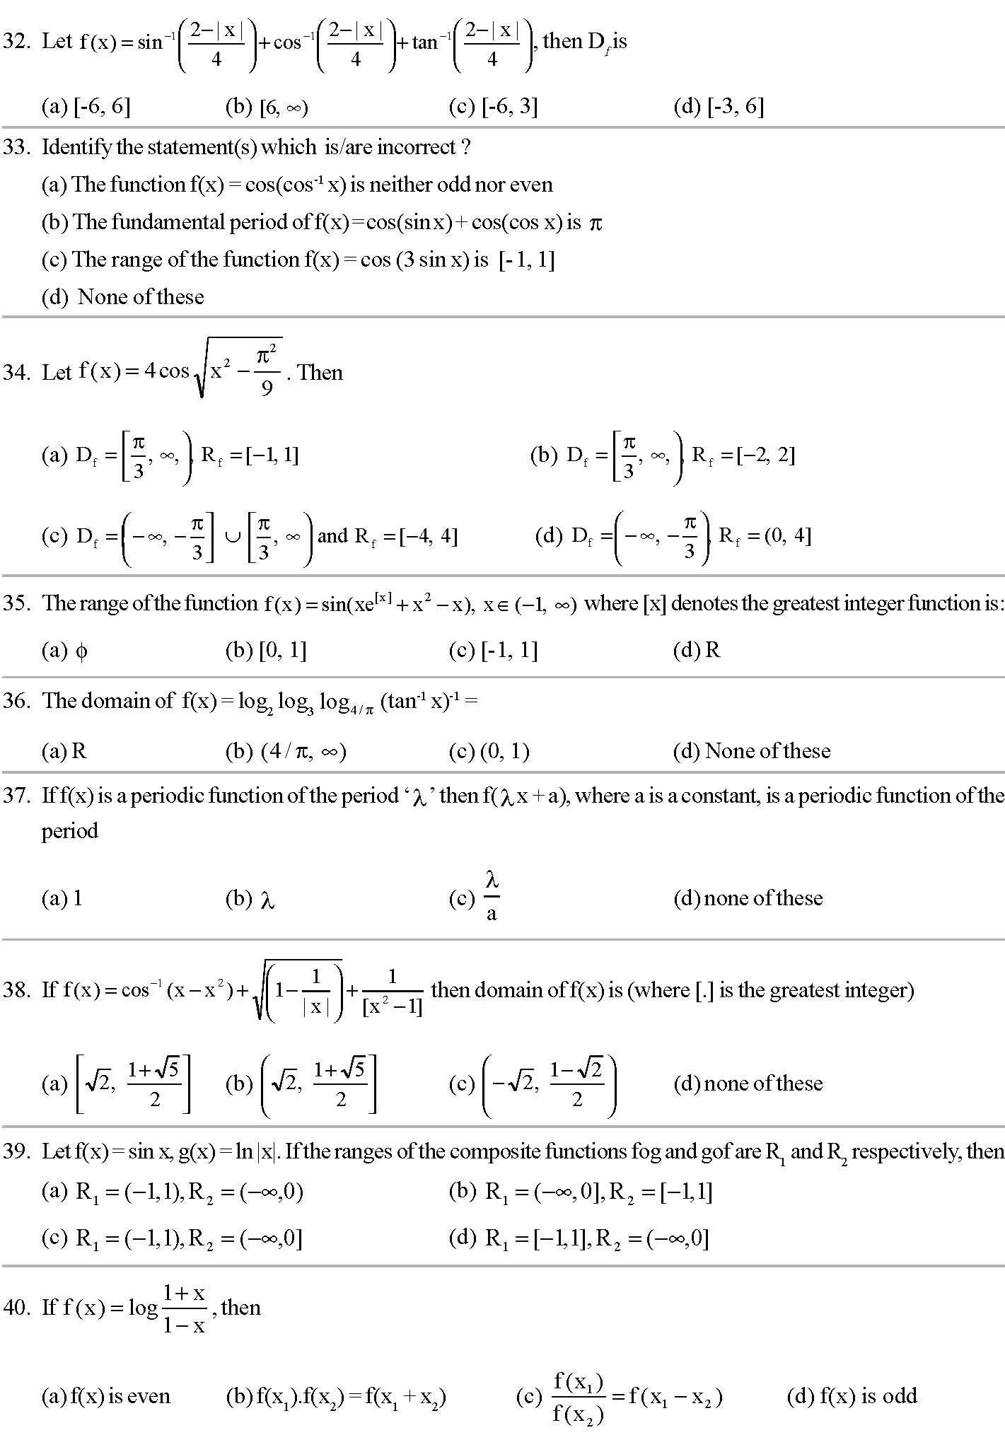
Exercise level 2:
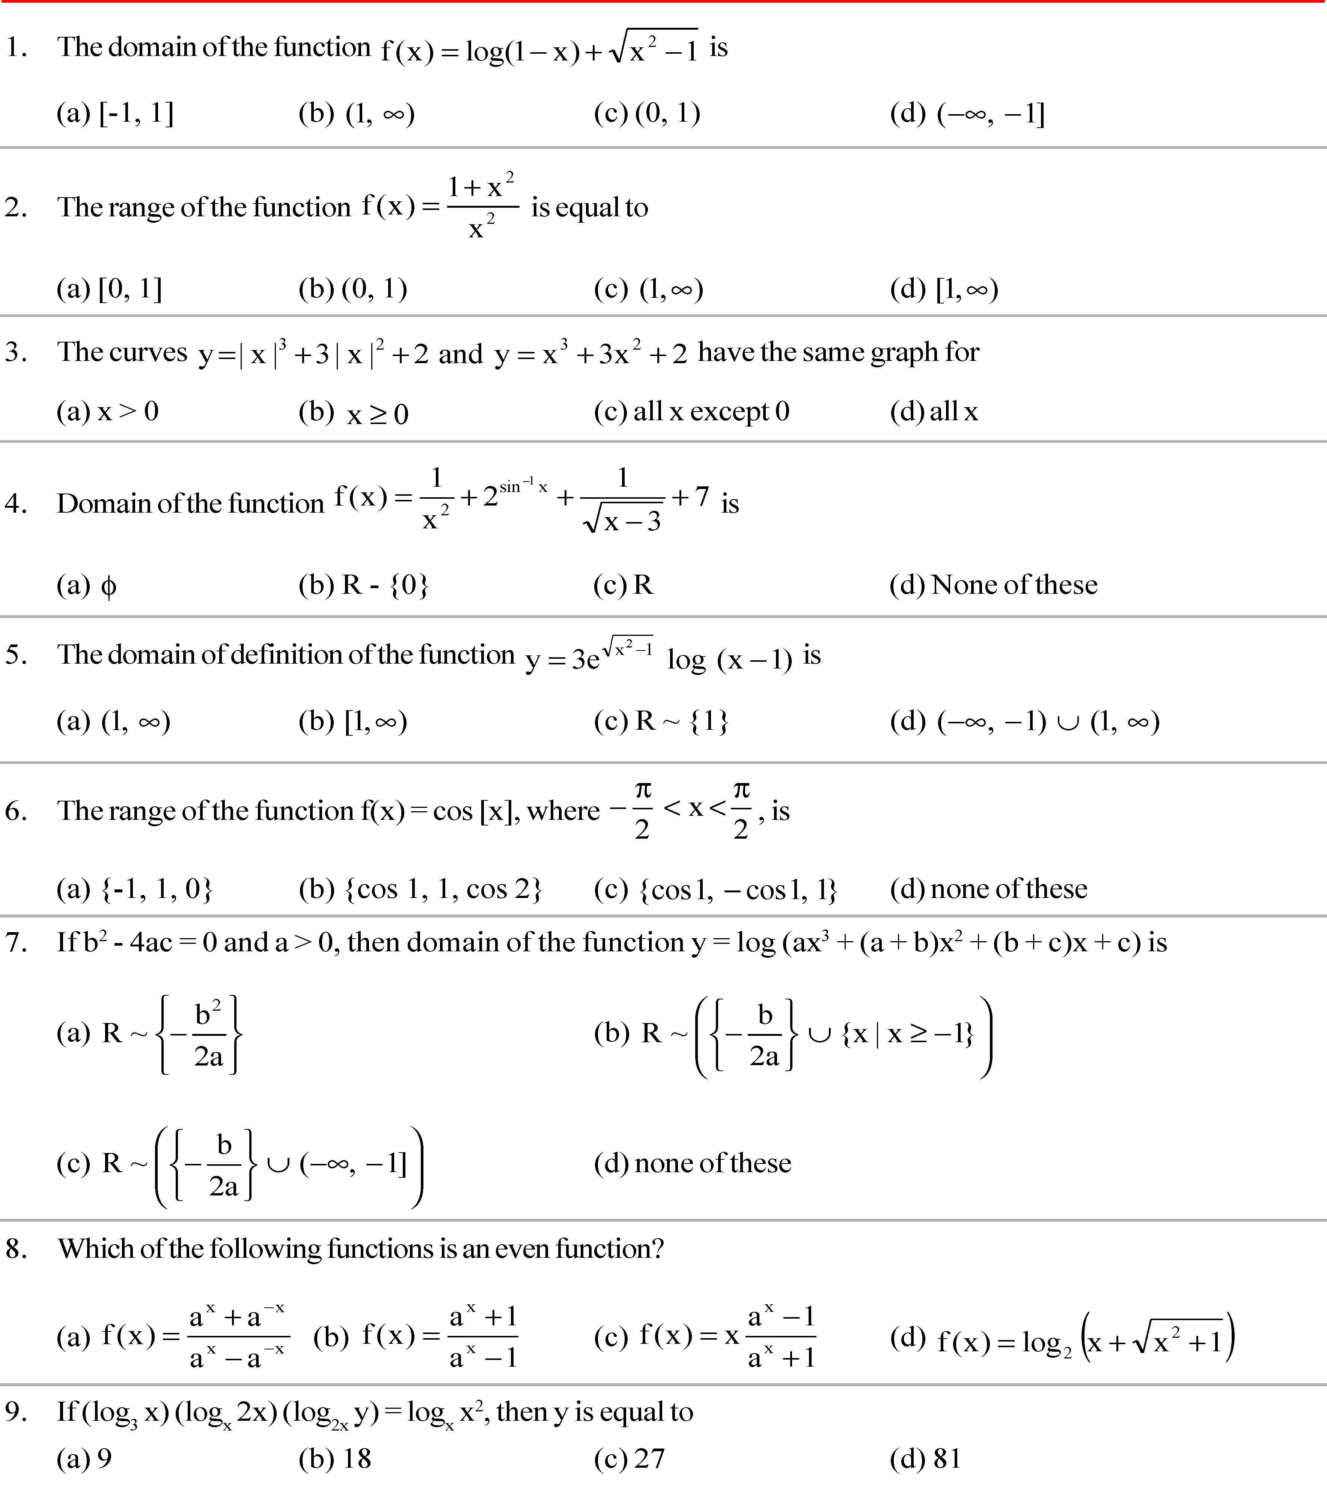
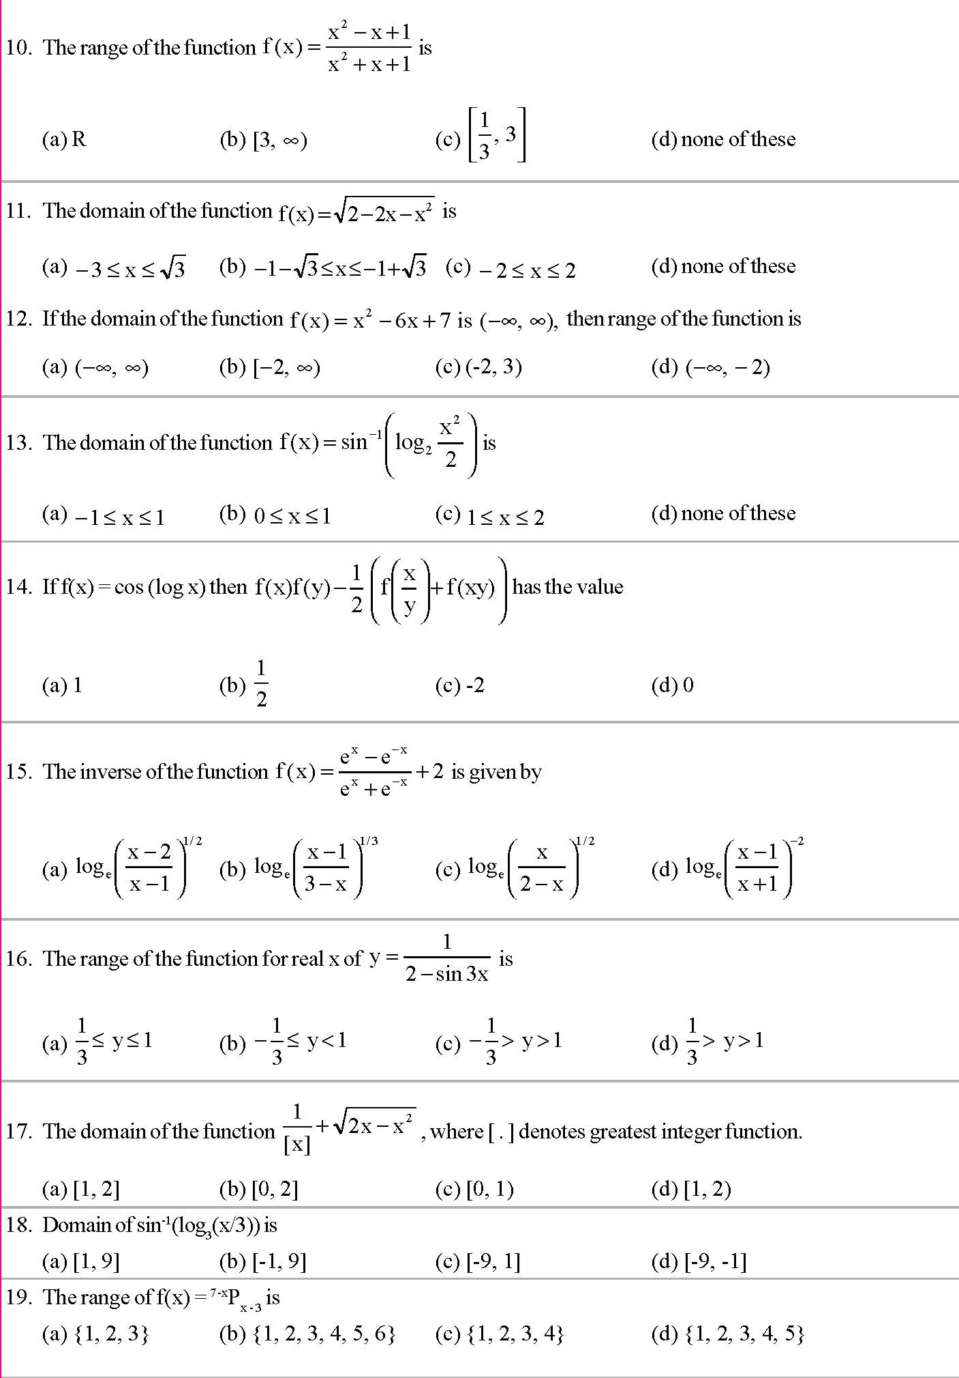
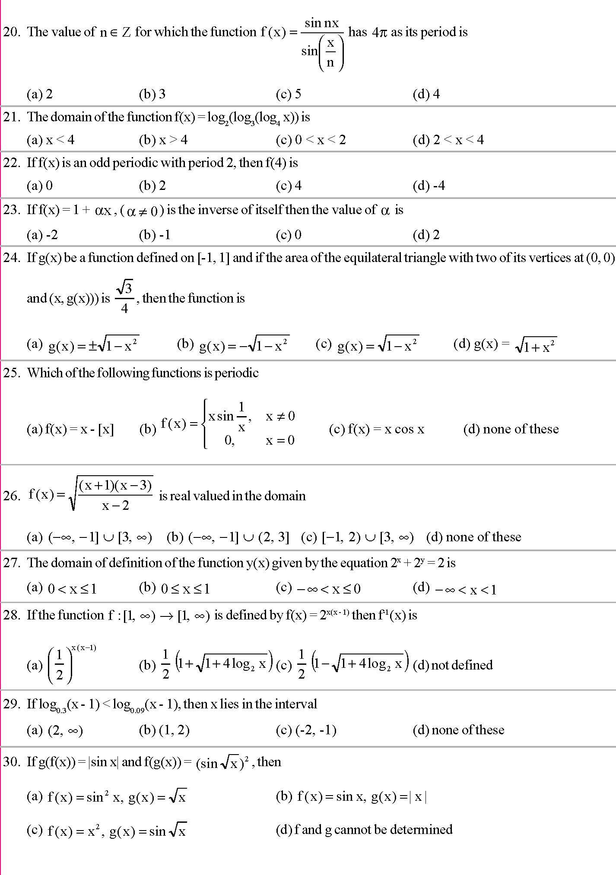
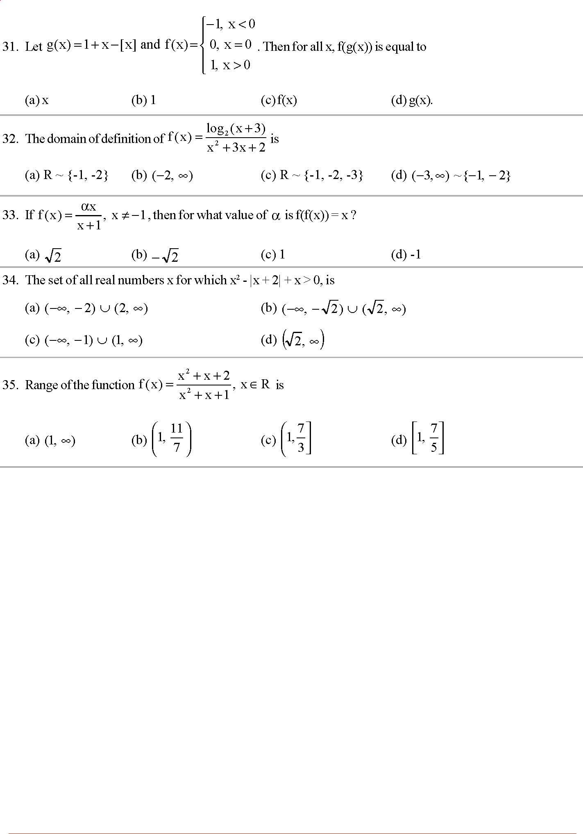
Exercise level 3 :
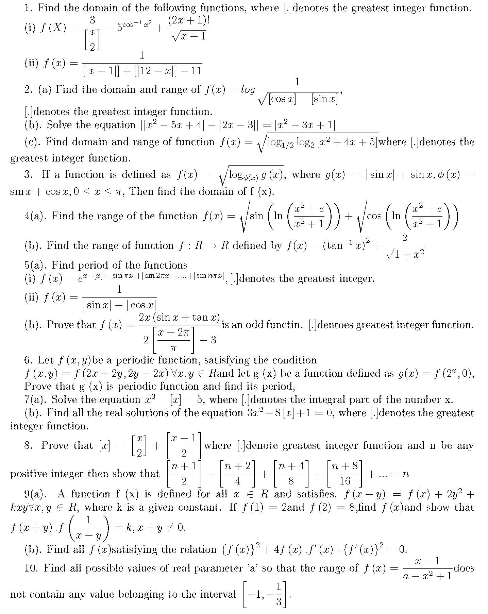

 Exercise level 1 :
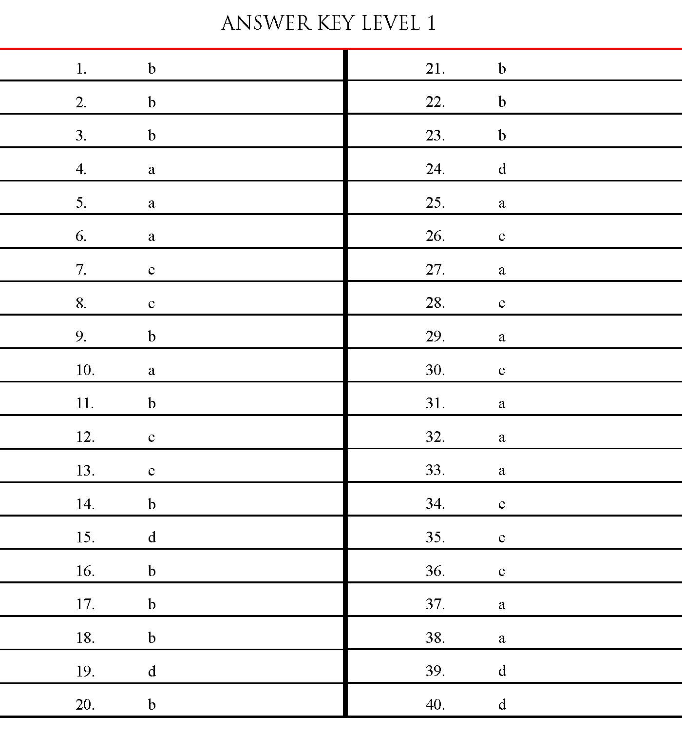

Exercise level 2:
